Health & Wellness News

September 2019

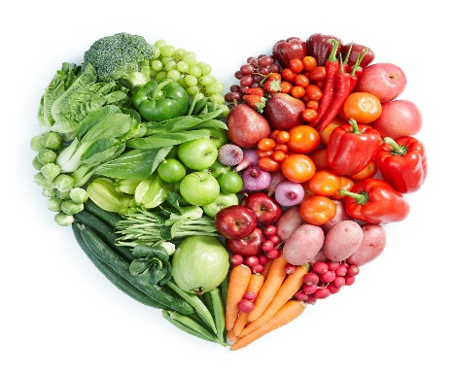

SNACKS

A significant portion of kids’ daily calories come from snacks — and if they’re eating processed, grain-based snack foods (like many of the popular, heavily-marketed options out there), many of those calories might be coming from added sugars. For healthy growth and development, make fruits, vegetables, whole grains and low-fat/fat-free dairy products the primary choices. • Portion control is very important — snacks should be served in appropriate portion sizes for a child’s age, size and activity level. • Read labels to choose snacks with less added sugar.

The benefits of eating more fruits and vegetables go far beyond helping to maintain a healthy weight. Think about better skin, fewer wrinkles, healthier teeth and gums and lower risk of diseases. As parents, we can play a big role in helping our families load up on vitamin-packed fruits and vegetables — by serving more at home, increasing the variety and quantity available and setting a good example by eating them ourselves. Try these creative ideas to boost fruit and veggie consumption at your house:

* Try making smoothies or slushes. Blend ice with fruit and some yogurt or a little low-fat milk, and your kids can “drink their fruit.” You can even sneak in some ONE carrots for a delicious breakfast beverage. Put some grapes or bananas in the freezer to make fruit more fun. These cold, healthy treats can be eaten like popsicles!
* Serve raw veggies with ranch dip or some salsa to add a little zip. Your family will love these crunchy treats packed with zesty flavor. Keep carrots in a glass of water to keep them crisp and ready for a fast snack.
* Add veggies or fruit to the baked goods your family already loves. Blueberry pancakes and carrot muffins are always a big hit – and healthy, too!
* Serve your soups, stews and sauces with extra veggies. Sneak them in, shredded or cooked, and your family will get a healthy bonus. They may not even notice!
* Get fruity with your peanut butter! Serve apple slices or grapes with peanut butter, or try a peanut butter and banana sandwich.

**September is National Fruits and Vegetables month! Celebrate through the fall months by eating healthy snacks made with seasonal foods.**

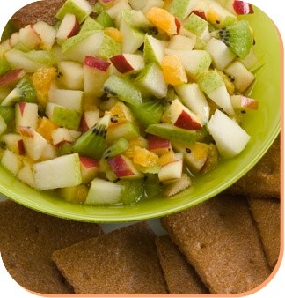

**Resources:**

ActionforHealthyKids.org • 600 W. Van Buren St., Suite 720, Chicago, IL 60607 • 800.416.5136

[*https://parentsforhealthykids.org/*](https://parentsforhealthykids.org/)

[*https://www.pinterest.com/act4healthykids/*](https://www.pinterest.com/act4healthykids/)

Pear Salsa

* 1 Pear. Choose firm pears. Apply gentle pressure to the neck of the pear with your thumb. When the pear gives in to the pressure, it is ready to eat.
* 1 Apple
* 2 Kiwis
* 1 Orange
* 2 tablespoons of honey
* 1 teaspoon lemon juice
* Cinnamon graham crackers or other whole grain crackers
* Mixing bowl
* Cutting board
* Serving spoon
* Knife

Directions: Core and/or chop all fruit into fine, bite-sized pieces. Combine chopped fruit in a medium bowl. Pour honey and lemon juice over the fruit and gently toss. Scoop bites of fruit salsa on crackers. Eat and enjoy!

Healthy Snack Recipe

*Fruit ideas*

Fresh whole or sliced fruit assortment • Fruit salad or kabobs • Dried fruit or 100% fruit leathers • Frozen fruit (try frozen grapes!) • Sliced apples with cinnamon • Unsweetened applesauce • 100% fruit popsicles • Banana pops — bananas, sliced in half, popsicle sticks inserted, rolled in yogurt and whole grain cereal toppings and frozen freeze

*VEGGIE IDEAS*

*Raw vegetables:* (baby carrots, sugar snap peas, sliced bell peppers and more) with low-fat dip • Celery topped with peanut butter and raisins or cream cheese and 100% fruit preserves • Edamame — boiled soybeans served in the pods

*Dips:* hummus, salsa, bean dip, honey mustard, Greek yogurt