Walk to School Wednesday
On the 1st Wednesday of each month (except March) the Still Elementary PTA, Wellness Committee, and PE Department will host a Walk to School Wednesday. Students will depart from Mountain View Church and walk the ½ mile to school. Students will receive a token for participating in Walk to School Wednesday. These tokens can be added to the Morning Walking Club chains. Students must be escorted by an adult for the walk. Walks will begin at 7:00 and end at 7:30. Walk to School Wednesday Dates:
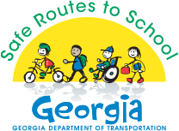
September 7th
October 5th NATIONAL WALK TO SCHOOL DAY
November 2nd
December 7th
January 11th
February 1st
March 8th GEORGIA WALK TO SCHOOL DAY
April – No Walk to school day due to Spring Break and Testing
May 3rd

Please check out http://www.saferoutesga.org/ for pedestrian safety tips and other Safe Routes to School information.

IF YOU CAN VOLUNTEER FOR WALK TO SCHOOL WEDNESDAY PLEASE CONTACT ABBY.BALKEMA@COBBK12.ORG

